Supplementary Figure Coverage of each genome. “<” indicates recipient and “>” indicates donor locations of genes suspected to be involved in homoeologous exchange.

Supplementary Figure Coverage of each genome. “<” indicates recipient and “>” indicates donor locations of genes suspected to be involved in homoeologous exchange.

Supplementary Figure Coverage of each genome. “<” indicates recipient and “>” indicates donor locations of genes suspected to be involved in homoeologous exchange.

Supplementary Figure Coverage of each genome. “<” indicates recipient and “>” indicates donor locations of genes suspected to be involved in homoeologous exchange.

Supplementary Figure Coverage of each genome. “<” indicates recipient and “>” indicates donor locations of genes suspected to be involved in homoeologous exchange.

Supplementary Figure Coverage of each genome. “<” indicates recipient and “>” indicates donor locations of genes suspected to be involved in homoeologous exchange.

Supplementary Figure Coverage of each genome. “<” indicates recipient and “>” indicates donor locations of genes suspected to be involved in homoeologous exchange.

Supplementary Figure Coverage of each genome. “<” indicates recipient and “>” indicates donor locations of genes suspected to be involved in homoeologous exchange.

Supplementary Figure Coverage of each genome. “<” indicates recipient and “>” indicates donor locations of genes suspected to be involved in homoeologous exchange.

Supplementary Figure Coverage of each genome. “<” indicates recipient and “>” indicates donor locations of genes suspected to be involved in homoeologous exchange.

Supplementary Figure Coverage of each genome. “<” indicates recipient and “>” indicates donor locations of genes suspected to be involved in homoeologous exchange.

Supplementary Figure Coverage of each genome. “<” indicates recipient and “>” indicates donor locations of genes suspected to be involved in homoeologous exchange.

Supplementary Figure Coverage of each genome. “<” indicates recipient and “>” indicates donor locations of genes suspected to be involved in homoeologous exchange.

Supplementary Figure Coverage of each genome. “<” indicates recipient and “>” indicates donor locations of genes suspected to be involved in homoeologous exchange.

Supplementary Figure Coverage of each genome. “<” indicates recipient and “>” indicates donor locations of genes suspected to be involved in homoeologous exchange.

Supplementary Figure Coverage of each genome. “<” indicates recipient and “>” indicates donor locations of genes suspected to be involved in homoeologous exchange.

Supplementary Figure Coverage of each genome. “<” indicates recipient and “>” indicates donor locations of genes suspected to be involved in homoeologous exchange.

Supplementary Figure Coverage of each genome. “<” indicates recipient and “>” indicates donor locations of genes suspected to be involved in homoeologous exchange.

Supplementary Figure Coverage of each genome. “<” indicates recipient and “>” indicates donor locations of genes suspected to be involved in homoeologous exchange.

Supplementary Figure Circos plot of Da-Ae. Outer blue track is read coverage across the Da-Ae genome. Inner green track is read coverage across the in silico genome (B. rapa + B. oleracea). Blue dots indicate standardized coverage greater than 1 and red dots indicate standardized coverage less than -1. Ribbons in the center of the plot indicate regions of homology between the A and C subgenomes. Colors have been assigned based on C subgenome chromosomes.

Supplementary Figure Circos plot of Darmor-bzh. Outer blue track is read coverage across the Da-Ae genome. Inner green track is read coverage across the in silico genome (B. rapa + B. oleracea). Blue dots indicate standardized coverage greater than 1 and red dots indicate standardized coverage less than -1. Ribbons in the center of the plot indicate regions of homology between the A and C subgenomes. Colors have been assigned based on C subgenome chromosomes.

Supplementary Figure Circos plot of Tapidor. Outer blue track is read coverage across the Da-Ae genome. Inner green track is read coverage across the in silico genome (B. rapa + B. oleracea). Blue dots indicate standardized coverage greater than 1 and red dots indicate standardized coverage less than -1. Ribbons in the center of the plot indicate regions of homology between the A and C subgenomes. Colors have been assigned based on C subgenome chromosomes.

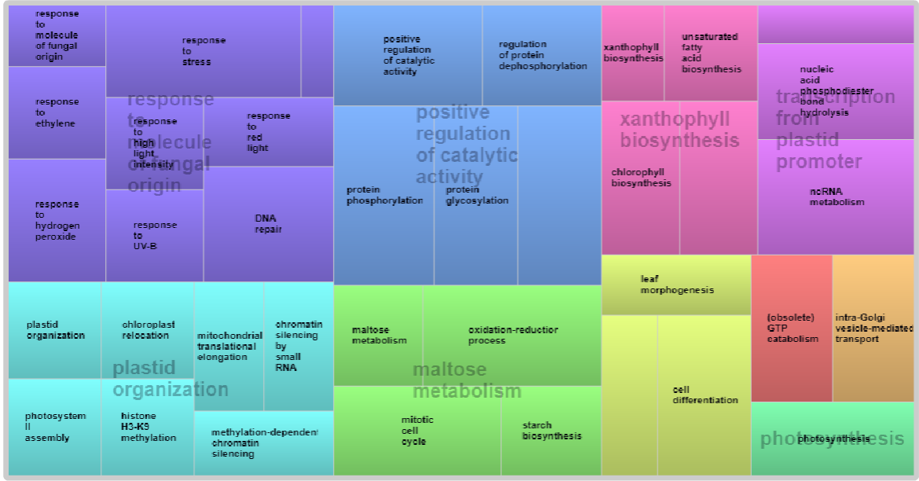

Supplementary Figure Revigo results for Biological Processes connected to the shared single copy BUSCOs